**STA 471 – Regression Analysis**

**Homework #4**

**October 19th, 2023**

Richard McCormick

RLM443

We define:

A = , B = , C =

Calculate the matrices below, or say it is impossible to do so, if it is impossible to.

1. B + C



1. BB′

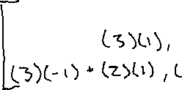

1. A + B′B

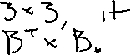

1. BC

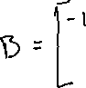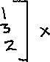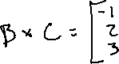

1. AA-1BC

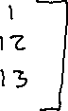

1. CB′

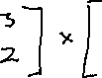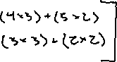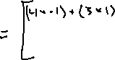

1. CAB



1. BC-1, where C-1 =

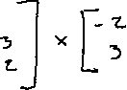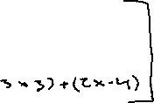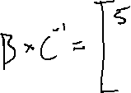

1. A-1

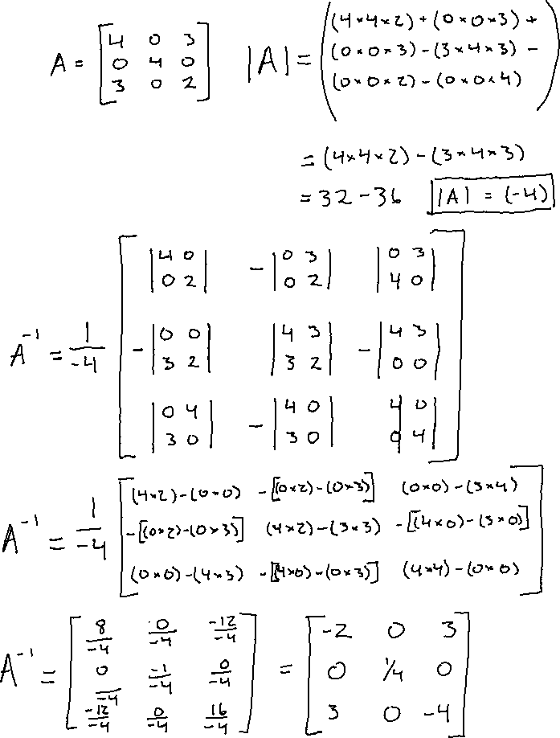

1. A′A(A′)-1A-1

